iTourism Travel Buddy Mobile Application

Afiza Ismail, Syed Abdullah Syed Abdul Kadir, AzharAbdul Aziz, Mudiana Mokshin, Anitawati Mohd Lokman

Faculty of Computer and Mathematical Sciences, Universiti Teknologi MARA

Shah Alam, Selangor, Malaysia

fiza@tmsk.uitm.edu.my

Abstract— Malaysia is a melting pot that encompasses extremely

diversified cultures, ethnicity, religions and languages. Tourist

information in the country is commonly found in the form of

printed materials as well as printed maps. This leads to issues like

environmentally unfriendly, less visibility in promoting the

tourism potential as well as an ineffective way to disperse

information. The work attempts to provide a solution to this

problem by providing a tourism mobile application that supports

tourism information with assistive travel features to ease tourists

by using technology that is closest to them. The project adopted

the RAD in the process of design and development of the

application, employing an interview approach to international

tourists at the airport, observation to existing assistive tourist

systems, and conducts a survey using questionnaires to potential

users. The result enables the work to develop the iTourism mobile

application in order to meet the demand of tourists. The results

revealed that there are major suggestions relating to the need for

a travel mobile application to assist tourists in finding interesting

places as well as related services. This mobile application is

important for Tourism Malaysia in order to enhance its

performance in promoting Malaysia locally and internationally.

The tourism industry can also capitalise on the advantage of this

application in order to gain visitor feedback on their products or

services. The application also offers tourist a secured journey, as

they can recheck the information and places of interest as it is

enhanced with GPS features.

Keywords- Mobile application, Rapid Application Development,

Tourism

I.

I

NTRODUCTION

Tourism and Hospitality is one

**CHAPTER: 01**

**INTRODUCTION**

**1.1 OVERVIEW:**

As someone who travels often, it is a challenge for me to connect with the local people and culture where I travel. Problems can happen when someone travels to a whole new country where local people have different type of thinking, culture, beliefs, etc. This application come out to help tourist to get quick and better view about where they are about to visit, as well as better connects with local people and reduce the chance that troubles happen along the journey.

In present era, there is no such app which makes the process of finding the attractions and places to eat and stay in new cities where you are a complete stranger.

Using the online travel companion app makes such process very easy. The purpose of this project is to make a full functioning travel companion app that allow users to search and view restaurants, hotels and tourist attractions based on different filters like there rating. The basic cost their reviews, contact details and much more are also very easily accessible.

**1.2 PROJECT OBJECTIVE**

* Travel-Bud’s main objective is to help users easily access details of restaurants, hotels and attractions in a particular location.
* The purpose of the is to build an application program to reduce the process of travelers and tourists to find different things.
* Travel-Bud must provide:
  + Ability for users to search a particular location
  + Various options of the required fields.
  + Display of the places on map to provide directions
  + Contact information
  + Pricing range
  + Reviews of the places.

**PROJECT SCOPE**

* This is online travel companion app.
* By which user can view the details of hotels, tourist attractions and restaurants of a particular place.
* User can view details from anywhere through internet and can access the directions to the location.

**1.3 ORGANIZATION OF REPORT**

**The following report consists of 10 chapters namely:**

Introduction, Background And Literature Survey, Process Model, Design, Technical

Details, Screen Layouts, Future Enhancements and conclusion.

First, we explain the challenge, motive, approach and the objective and scope of our project. Then, we talk about its software requirement specification, utility and market opportunities and the proposed project model. After that we discuss the

proposed process model, project plan and the timeline of our project which are

followed by all the relevant diagrams. Then we specify some hardware and software

requirements and post snippets of some code and talk about testing our prototype

and sharing the screen layouts of our result. Finally, we discuss the future

enhancements and concluded the report.

**CHAPTER : 02**

**BACKGROUND AND LITERATURE SURVEY**

**2.1 SOFTWARE REQUIRMENT SPECIFICATION:**

**2.1.1 Functional Requirements:**

The purpose of the application is to create an environment for people who travels often to meet locals.

This section provides requirement overview of the system. Various functional modules that can be implemented by the system will be-

**Access to location:**

User has to allow the website to access the location if one wants to know the directions.

**Search:**

Search with appropriate keywords or name of the city.

**Map view:**

The system will also provide the details of those places you want to access on a map.

**Report Generation:**

After ordering for the book, the system will send one copy of the bill to the customer’s Email-address and another one for the system data base.

**2.1.2 NON- FUNCTIONAL REQUIRMENTS**

**Reliability**

The system shall be completely operational all the time . Genuine products are only shown on the list for user satisfaction and better quality. Secure access to consumer’s confidential data.

**Performance**

The website is able to support 100 concurrent users without any performance degradation . Its performance may vary according to the given inputs.

**Manageability Requirement**

Better component design to get better performance at peak time . The system is developed in such a way that it can be easily reused , deployed and tested**.**

**2.1.3 Performance Requirements:**

In order to maintain an acceptable speed at maximum number of uploads allowed from a particular customer as any number of users can access to the system at any time. Also the connections to the servers will be based on the attributes of the user like his location and server will be working 24X7 times.

**2.1.4** **Interface Requirement:**

Various interfaces for the product could be

1). Main interface

2). Search bar

3). There will be a screen displaying information about the place that user wants

4). If the customers click the location, then another screen will take you that particular detailing.

* 1. **FEASIBILITY REPORT**

Feasibility is an important phase in the software development process it enables the developer to have an assessment if the product being developed it refers to the feasibility study of the product in terms of outcomes of the product, operational required for implementing it .

**2.21 Innovativeness and usefulness**

The application requires no special technical guidance and all the views available in the application are self-explanatory. The users are well guided with warning and failure messages for all the actions taken. That means the product is economically feasible. The only cost involved is having a computer with the minimum requirements mentioned earlier. For the users to access the application, the only cost involved will be in getting access to the Internet.

* This product is operationally feasible too as it is designed specifically for E-Governance . This provides consistent and integrated data management . it also provides information at all levels .
* The application requires no special technical guidance and all the views available in the application are self-explanatory. The users are well guided with warning and failure messages for all the actions taken.
* The system has been added with the features of menu device and button interaction methods , which makes them the master as the person starts working through the environment . As the software that were used as developing this application are very economical and are readily available is the market the time that lost by customer is just visiting the site time.

**2.2.2 Market Potential and Competitive advantages**

For knowing the market potential we collect the primary resources and secondary resources with marketing research, after doing marketing research, we see our target market; our customer focus and our competitors in the market .and we see what are the strengths and weakness of our business idea. Our plan is related to open an online book shop which name is ‘Pick-a-Book’.

**Industry Analysis :** Over the past several years, a new and powerful marketplace has emerged. This ever-changing frontier is known as the World Wide Web. Electronic commerce is increasingly becoming the preferred mechanism to transact business in India. The Internet enables online sellers to boost margins and reach new markets with virtually no restraints or regulation. The Indian textbook market is a large, growing, and fragmented business. Textbooks are written and marketed primarily for use in formal educational settings. Much of the demand for graduate level textbooks depends on growth in the population attending institutions of graduate study

**Political and legal environment :** In India political and legal environment is very supportive for entrepreneurship projects .the banks are providing a very low interest of loan on feasible entrepreneurship project.

**ADVANTAGES :**

1. Use of Internet as an information source for Travelers.

2. Customer Convenience.

3. Less Investment & fewer workforces for starting the venture.

4. Target market.

5. Minimum physical assets & less overhead charges on warehouses.

6. Users don’t have to find places manually.

**PROPOSED PROJECT MODEL**

**Model View Controller Model (MVC)**

Flux is the application architecture that Facebook uses for building client-side web applications. It complements React's composable view components by utilizing a unidirectional data flow. It's more of a pattern rather than a formal framework, and you can start using Flux immediately without a lot of new code.**Advantages of MVC model:**

Flux applications have three major parts: the dispatcher, the stores, and the views (React components). These should not be confused with Model-View-Controller. Controllers do exist in a Flux application, but they are controller-views — views often found at the top of the hierarchy that retrieve data from the stores and pass this data down to their children. Additionally, action creators — dispatcher helper methods — are used to support a semantic API that describes all changes that are possible in the application. It can be useful to think of them as a fourth part of the Flux update cycle.

Flux eschews MVC in favor of a unidirectional data flow. When a user interacts with a React view, the view propagates an action through a central dispatcher, to the various stores that hold the application's data and business logic, which updates all of the views that are affected. This works especially well with React's declarative programming style, which allows the store to send updates without specifying how to transition views between states.

We originally set out to deal correctly with derived data: for example, we wanted to show an unread count for message threads while another view showed a list of threads, with the unread ones highlighted. This was difficult to handle with MVC — marking a single thread as read would update the thread model, and then also need to update the unread count model. These dependencies and cascading updates often occur in a large MVC application, leading to a tangled weave of data flow and unpredictable results.

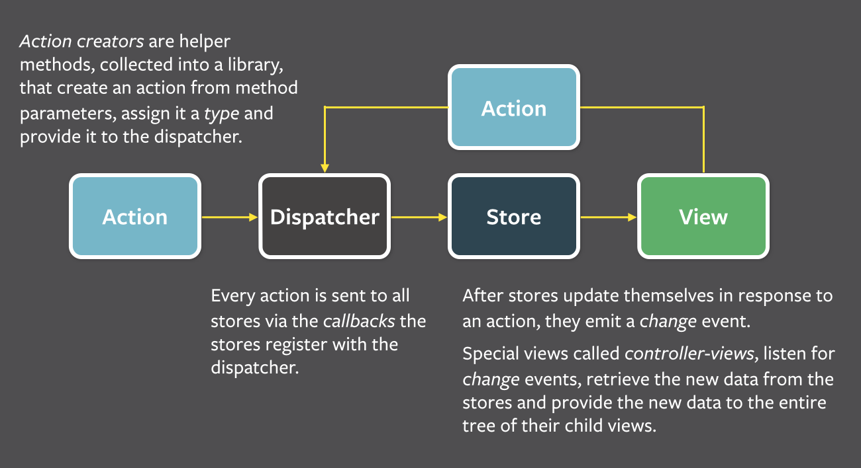

**Figure 2.1**

**CHAPTER:03**

**PROCESS MODEL**

**3.1 PROPOSED PROCESS MODEL**

**WATERFALL MODEL**

The waterfall model is a classical model used in system development life cycle to create a system with a linear and sequential approach. ... This model is divided into different phases and the output of one phase is used as the input of the next phase.

The waterfall model is a sequential approach, where each fundamental activity of a process represented as a separate phase, arranged in linear order. In the waterfall model, you must plan and schedule all of the activities before starting working on them (plan-driven process). The layers of waterfall model are :

**Requirement:** During this phase, detailed requirements of the software system to be developed are gathered from client.

**Design Stage:** Plan the frame work and the languages that are user as well as the api’s that are required.

**Built Stage:** After design stage, it is built stage, that is nothing but coding the software

**Test Stage:** In this phase, you test the software to verify that it is built as per the specifications given by the client.

**Maintenance stage :** After design stage, it is built stage, that is nothing but coding the software

**Advantages**

* Before the next phase of development, each phase must be completed
* Suited for smaller projects where requirements are well defined
* They should perform quality assurance test (Verification and Validation) before completing each stage
* Elaborate documentation is done at every phase of the software's development cycle
* Any changes in software are made during the process of the development

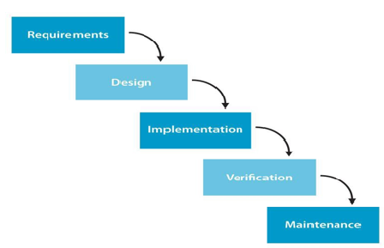

**Figure 3.1**

**3.2 PROJECT PLAN**

* **Inception Phase :**

The inception phase will define all the project’s requirements. This phase will include the production of a Vision Document, a Project Plan, a Software Quality Assurance Plan, and a Demonstration. The main objective of the project is to create an online book store that allows users to search and purchase a book based on title, author and subject. The selected books are displayed in a tabular format and the user can order their books online through credit card payment. The Administrator will have additional functionalities when compared to the common user.

* **Elaboration Phase :**

The elaboration phase defines the project’s architecture. This phase will include the production of revisions to the Project Plan and the Vision Document, an Architecture Design Plan, a formal specification, Test Plan, Formal Technical Inspection and Architecture Prototype.  we work on the efficiency of our architecture. In this phase, we also analyze use cases and other **s**oftware diagrams.

* **Production Phase :**

The production phase defines the project implementation and testing. This phase includes the user manual, component design, assessment evaluation, project evaluation, references, and formal technical inspection. The plan is such that.

It took us the span of 1 month to develop our project .

Firstly we discussed and finalized the features we wanted in our website and distributed the task to be performed by each member.

Then , We created the front-end of the website with all the features we wanted to provide our customers.

After that we created the database and complete our backend to activate all the features we have given in the website.

**3.3 PROJECT ESTIMATION AND SCHEDULING**

**GANT CHART :**

**Gantt charts** are useful for planning and scheduling projects. They help you assess how long a project should take, determine the resources needed, and plan the order in which you'll complete tasks. They're also helpful for managing the dependencies between tasks.

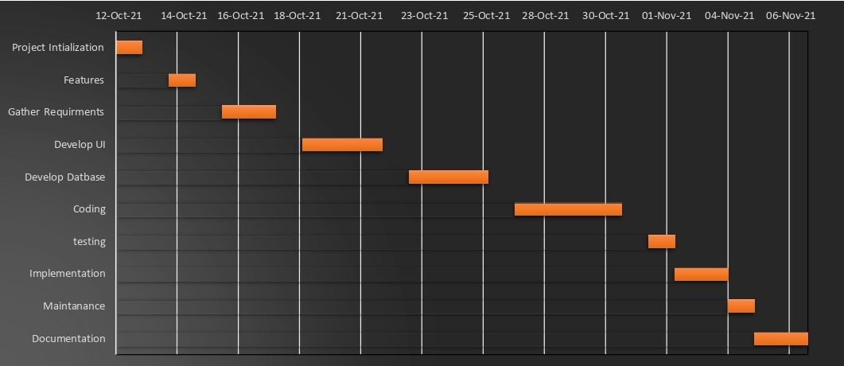

**Figure 3.2**

According to the above Gantt chart the production of the project completed in the following phase and timings.

**Project Initialization :** We initialized our project around 12th October .  We explore and elaborate the idea to identify if the project can realistically be completed and its goal achieved.

**Features :** We discusses andfinalized the features we wanted in our website like Registration page, login , product accessibility and other like administrator functionalities .

**Gather Requirements** : It took us 2 days to gather all the required software and the platform and download it to build our project. I used React framework and Visual Studio Code IDE

**Develop UI :** The task to design UI was done in the span of three days I used ReactJS Framework.

**Testing :** To test our project we used white box testing in which we tested the proper flow of the website.

**Implementation and Maintenance :** We completed this phase of implementation and maintenance in three days after which our website was finally ready to get presented.

**Documentation :** This was the last task of our project which took two days .

**CHAPTER : 04**

**DESIGN**

* 1. **USE CASE DIAGRAM**

A use case diagram at its simplest is a presentation of a user's interaction with the system that shows the relationship between the user and the different use cases in which the user is involved

.

**Web Customer** [actor](https://www.uml-diagrams.org/use-case-actor.html) uses some web site to make purchases online. Top level [use cases](https://www.uml-diagrams.org/use-case.html) are **View Items, Make Purchase** and **Client Register**. View Items use case could be used by customer as top-level use case if customer only wants to find and see some products. This use case could also be used as a part of Make Purchase use case. Client Register use case allows customer to register on the web site

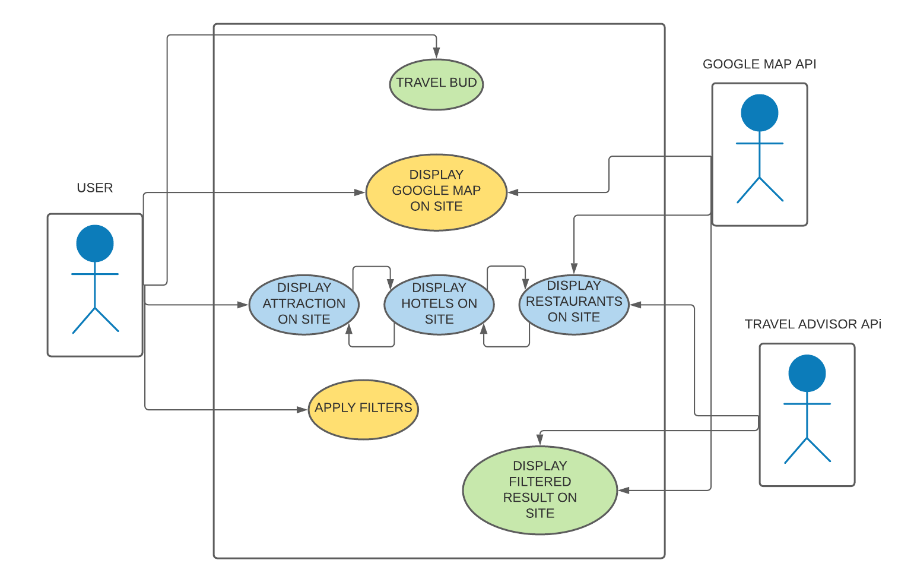

**Figure 4.1**

**4.2 SEQUENCE DIAGRAM :**

* A sequence diagram simply depicts interaction between objects in a sequential order i.e. the order in which these interactions take place.
* We can also use the terms event diagrams or event scenarios to refer to a sequence diagram. Sequence diagrams describe how and in what order the objects in a system function.
* A good design can have lots of small methods in different classes. Because it is difficult to figure out the overall behavior of the design, we draw a sequence diagram to verify the behavior.

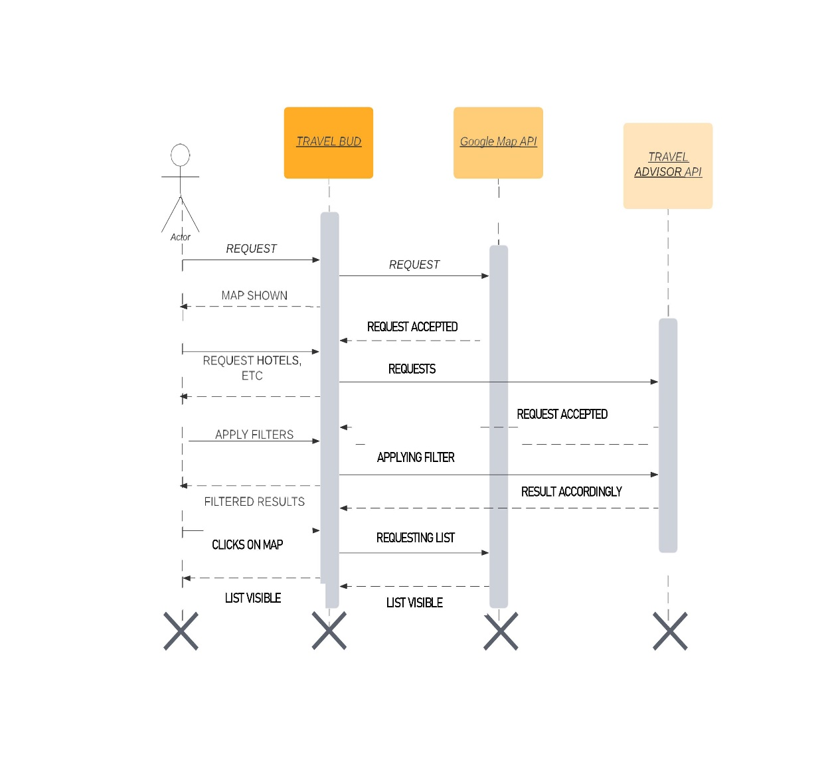

Figure 4.2

**4.3 ACTIVITY DIAGRAM:**

Activity diagram is another important behavioral diagram in UML diagram to describe dynamic aspects of the system. Activity diagram is essentially an advanced version of flow chart that modeling the flow from one activity to another activity.

Activity diagrams are an essential part of the modeling process. They are used to clarify complicated use cases, illustrate control among objects, or to show the logic of an algorithm.

**Activity Diagram For User:**

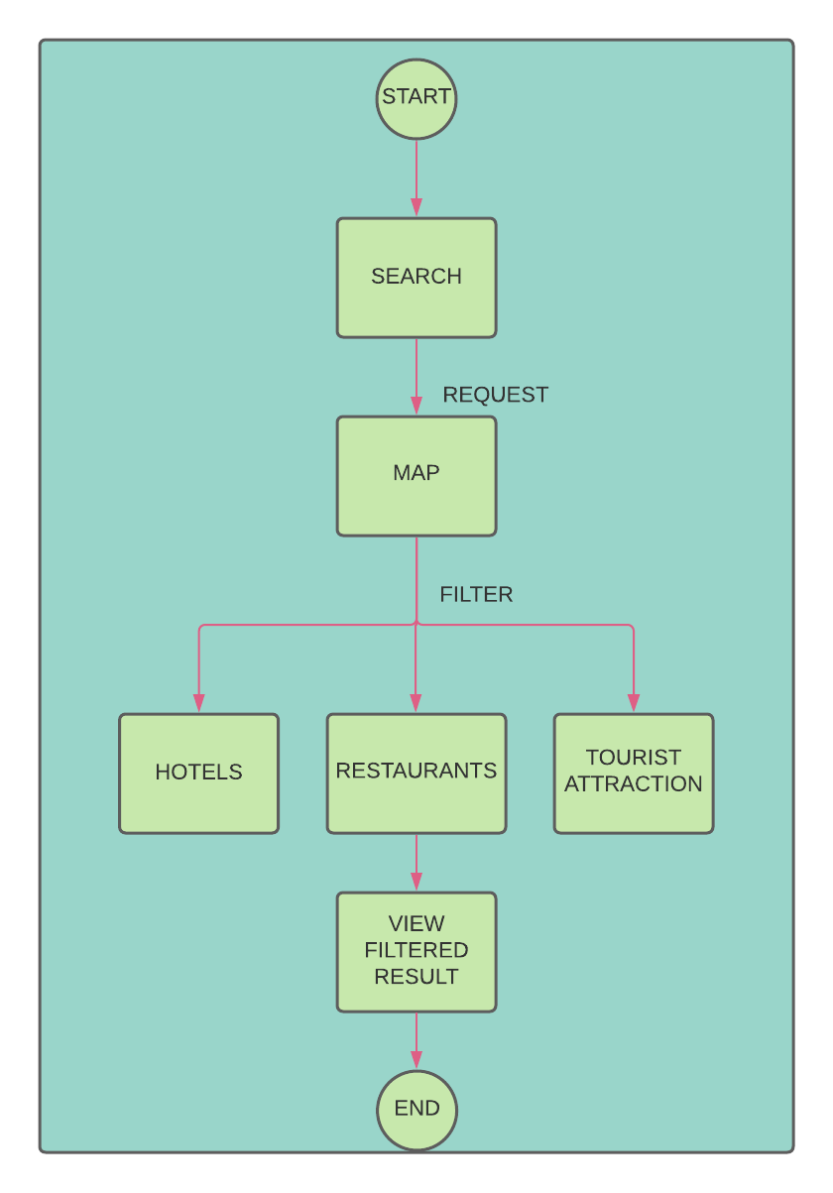

**4.4 CLASS DIAGRAM:**

In software engineering, a class diagram in the Unified Modelling Language (UML)is a type of static structure diagram that describes the structure of a System by showing the system's Classes, their attributes, operations (or methods), and the relationships among objects.

The class diagrams are widely used in the modeling of object-oriented systems because they are the only UML diagrams, which can be mapped directly with object-oriented languages. Class diagram shows a collection of classes, interfaces, associations, collaborations, and constraints.

**4.5 ER DIAGRAM:**

An ER diagram shows the relationship among entity sets. An entity set is a group of similar entities and these entities can have attributes. In terms of DBMS, an entity is a table or attribute of a table in database, so by showing relationship among tables and their attributes, ER diagram shows the complete logical structure of a database

ER diagrams are used to analyze existing databases to find and resolve problems in logic or deployment. Drawing the diagram should reveal where it's going wrong. Business information systems: The diagrams are used to design or analyze relational databases used in business processes.

**4.6 DATA FLOW DIAGRAM:**

A data-flow diagram is a way of representing a flow of a data of a process or a system. The DFD also provides information about the outputs and inputs of each entity and the process itself. A data-flow diagram has no control flow, there are no decision rules and no loops.

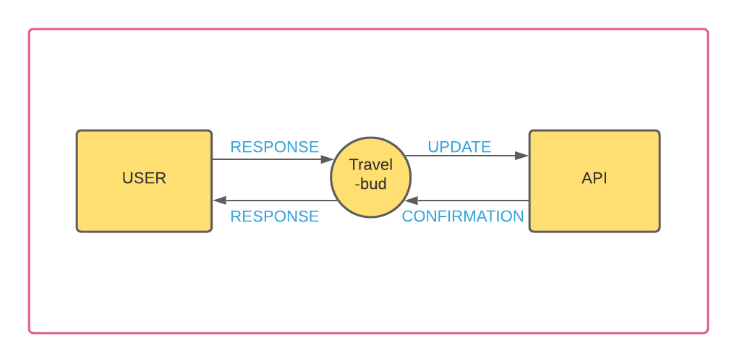

**Figure 4.4**

**4.7 FLOW CHART**

A flowchart is a picture of the separate steps of a process in sequential order. It is a generic tool that can be adapted for a wide variety of purposes, and can be used to describe various processes, such as a manufacturing process, an administrative or service process, or a project plan.

A flowchart is a diagram that represents a set of instructions . Flowcharts normally use standard symbols to represent the different types of instructions. These symbols are used to construct the flowchart and show the step-by-step solution to the problem.

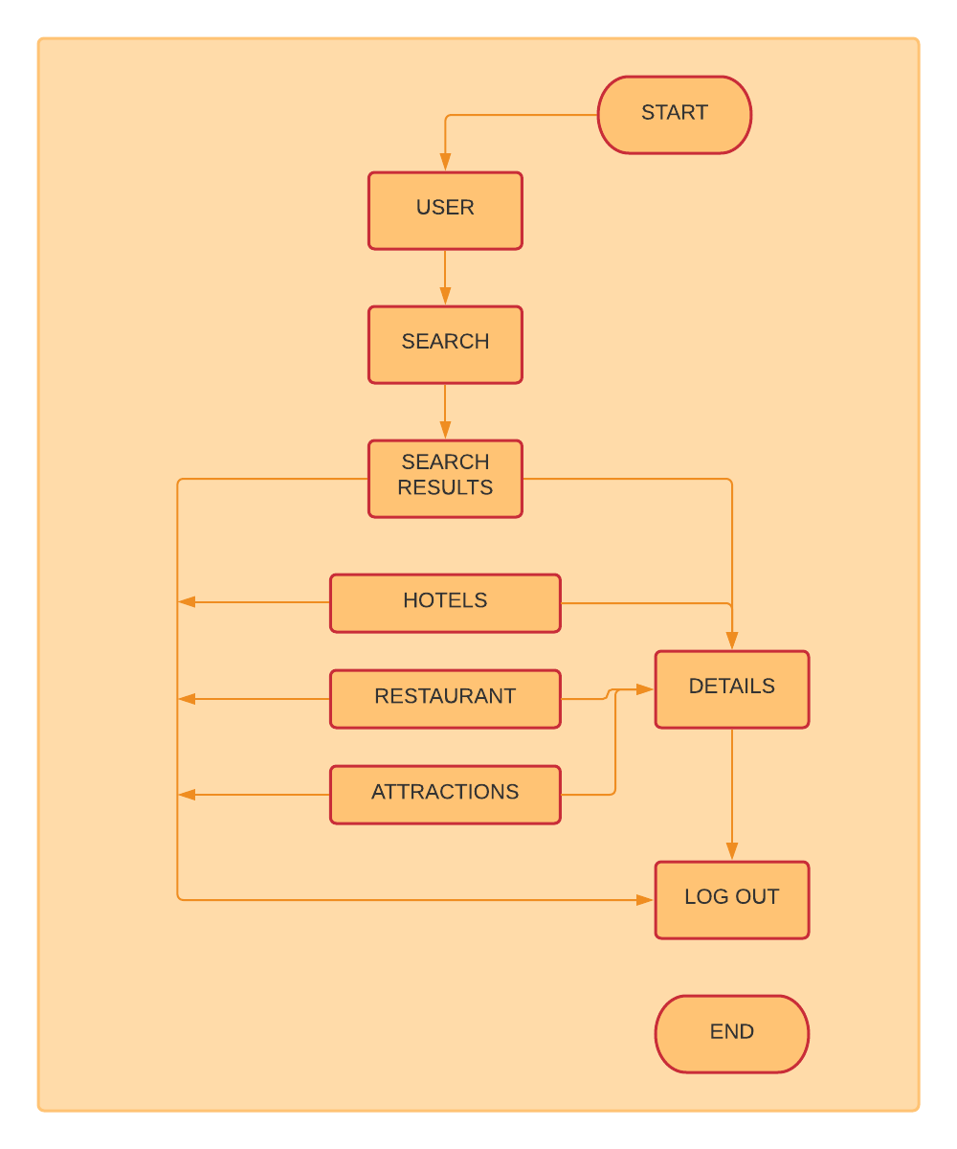

Figure 4.5

**4.8 ALGORITHM**

The word “algorithm” relates to the name of the mathematician Al-khwarizmi, which means a procedure or a technique. Software Engineer commonly uses an algorithm for planning and solving the problems. An algorithm is a sequence of steps to solve a particular problem or algorithm is an ordered set of unambiguous steps that produces a result and terminates in a finite time

**Algorithm of for The User**

Step 1 : Start

Step 2 : Search keyword

If (yes) Then

Go to View Item

Else

Garbage search

Step 3 :Click the place you want to view

See details

Step 4 : If required

View location in map

Step 5 : View the details

Step 6 : Exit

**CHAPTER: 05**

**TECHNICAL DETAILS**

**5.1 SOFTWARE SPECIFICATION**

1.**Operating System:**

Choosing an [operating system](https://www.wgu.edu/blog/5-most-popular-operating-systems1910.html) (OS) is the first decision to be made. This technology has the most familiar terms for non-techies in this project we have used [Microsoft Windows](https://www.microsoft.com/en-us/windows).

**2.** **API’s**

Google maps API, Geolocation API, and Rapid API, Travel Advisor API, Weather API, Google maps React API

**3.** **Databases**

There is no requirement of database for this project.

**4.Programming language**

Programming languages use different syntax to command a computer to do whatever is desired. JavaScript is used in our project for programming purpose.

**5**.**Front-End Technologies**

The front end is a client-facing suite of tech tools in web and app development. There are three main names here and the best thing is that there are no choices to be made (yes, no mistakes at this stage too).

* ReactJs Framework
* Material UI
* Java Script

**5.2 HARDWARE SPECIFICATION**

Computer hardware specifications are technical descriptions of the computer's components and capabilities. Computer hardware specifications are technical descriptions of the computer's components and capabilities. Processor speed, model and manufacturer.

**System Requirements for WEB**

* Use of Chrome browserMinimal Chrome version : Latest version
* Minimal Bandwidth of 0.75 Mbit/s upload and 0.75 Mbit/s download (*)
* (*) For one outbound video stream and one inbound video stream.
* The web app version of Reacts includes less features than the full version.

**System Requirements for Iphone/Ipad/MacOS**

* iPhone/iPad
* iOS 12 or higherMobile phone and tablet compatible

**System Requirements for Android**

* Android
* Android 9 or higher
* Mobile phone and tablet compatible.

**System Requirements for Windows**

* Windows 10
* Processor Base Frequency of 1.8 GHz or higher
* 4 GB RAM or more
* 75 MB of available disk space or more
* Minimal screen resolution: 1366x768 pixels
* Camera and Mic (USB or Built in)

For optimal performance with touchscreen devices :

* Graphics processing 20 EU’s / 400 GFLOPS or higher
* Intel HD Graphics GT2 (4200, 4400, 4600, P4600, P4700, 5000 … ) or higher
* NVidia GeForce 8800, 9800, 430, GTS or higher

**CHAPTER : 06**

**CODING**

**FOLDER STRUCTURE**

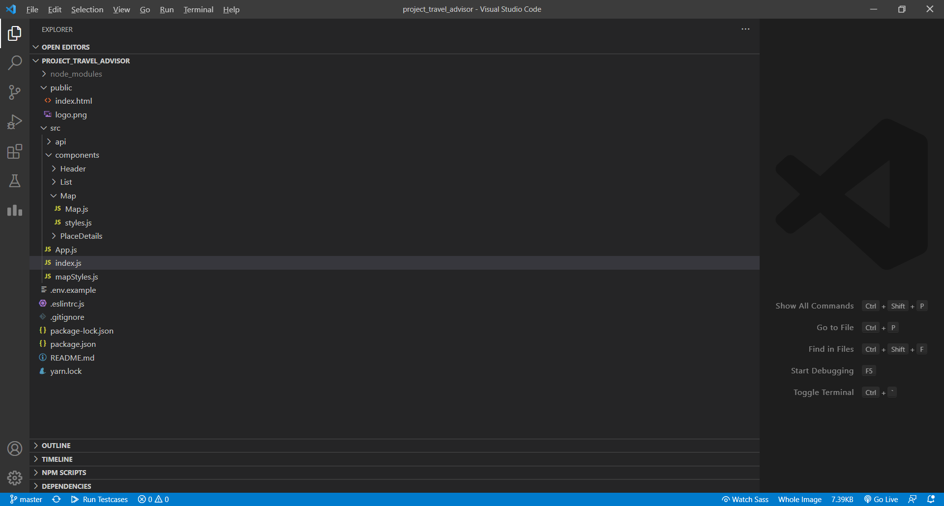

**MAIN COMPONENT: App.js**

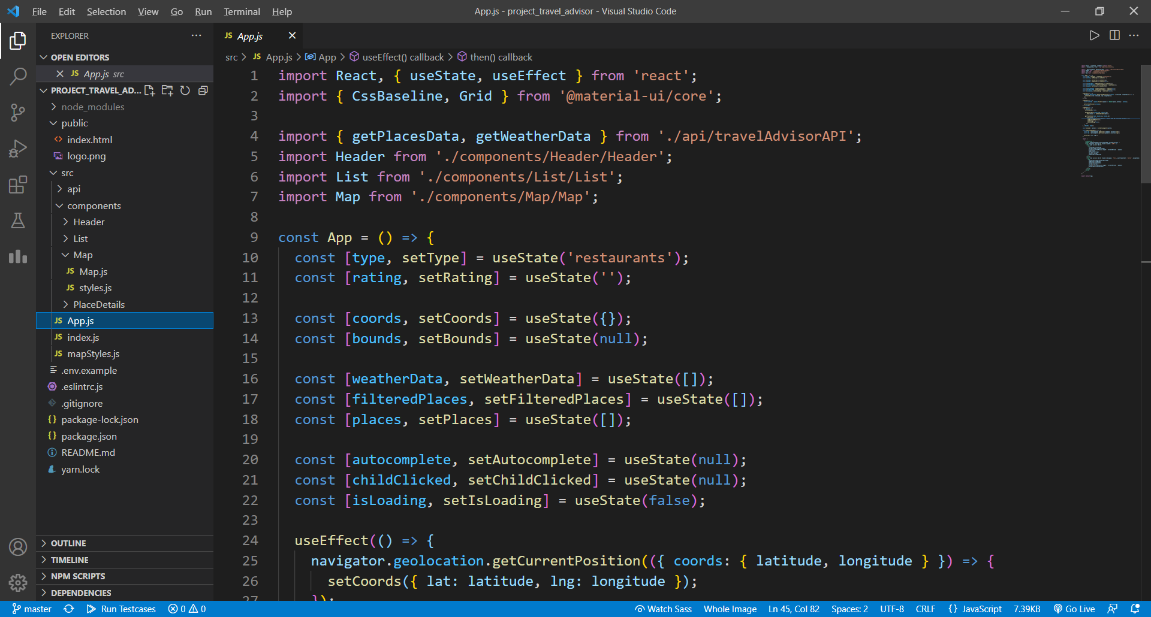

**Index.js COMPONENT**

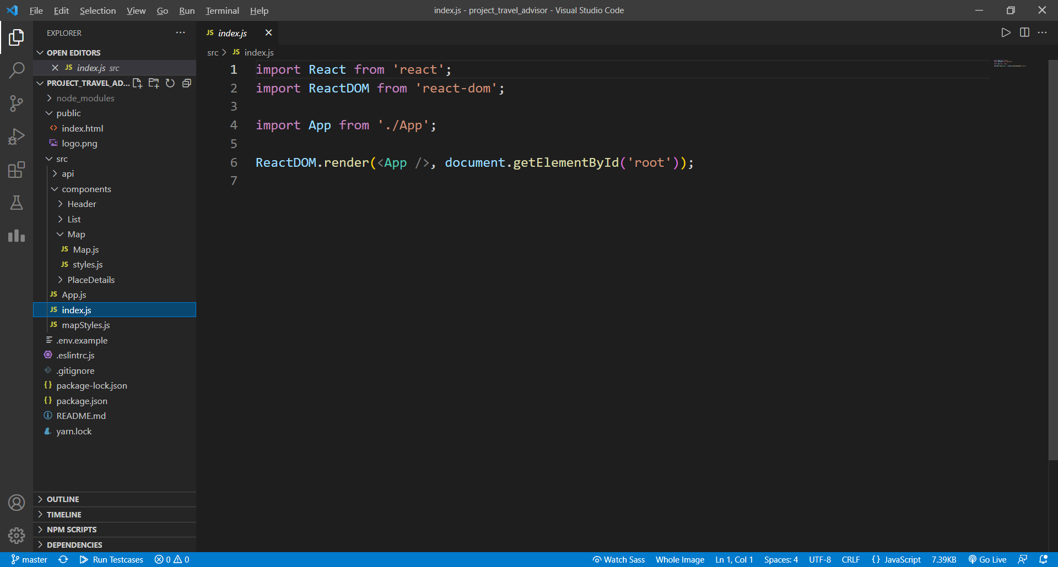

**Map.js COMPONENT TO RENDER MAPS**

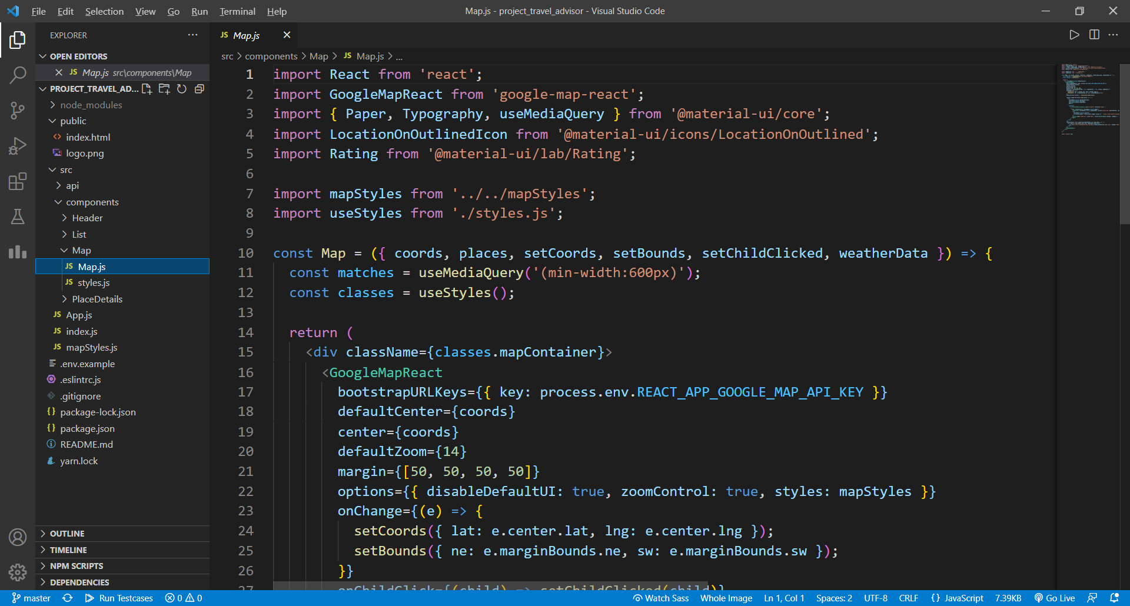

**Index.html FILE**

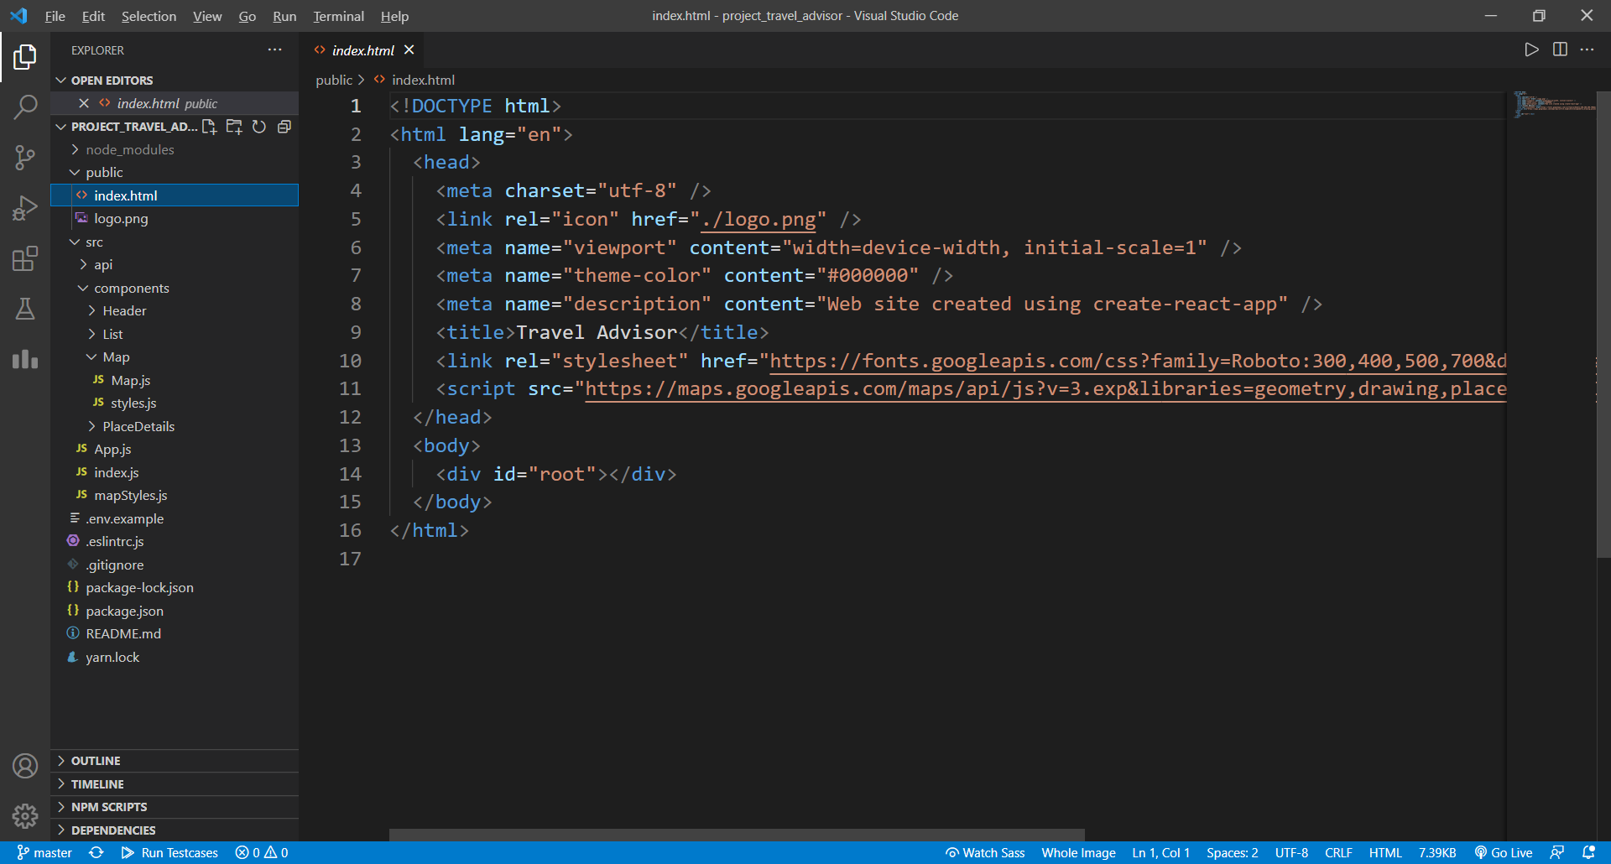

**Readme FILE**

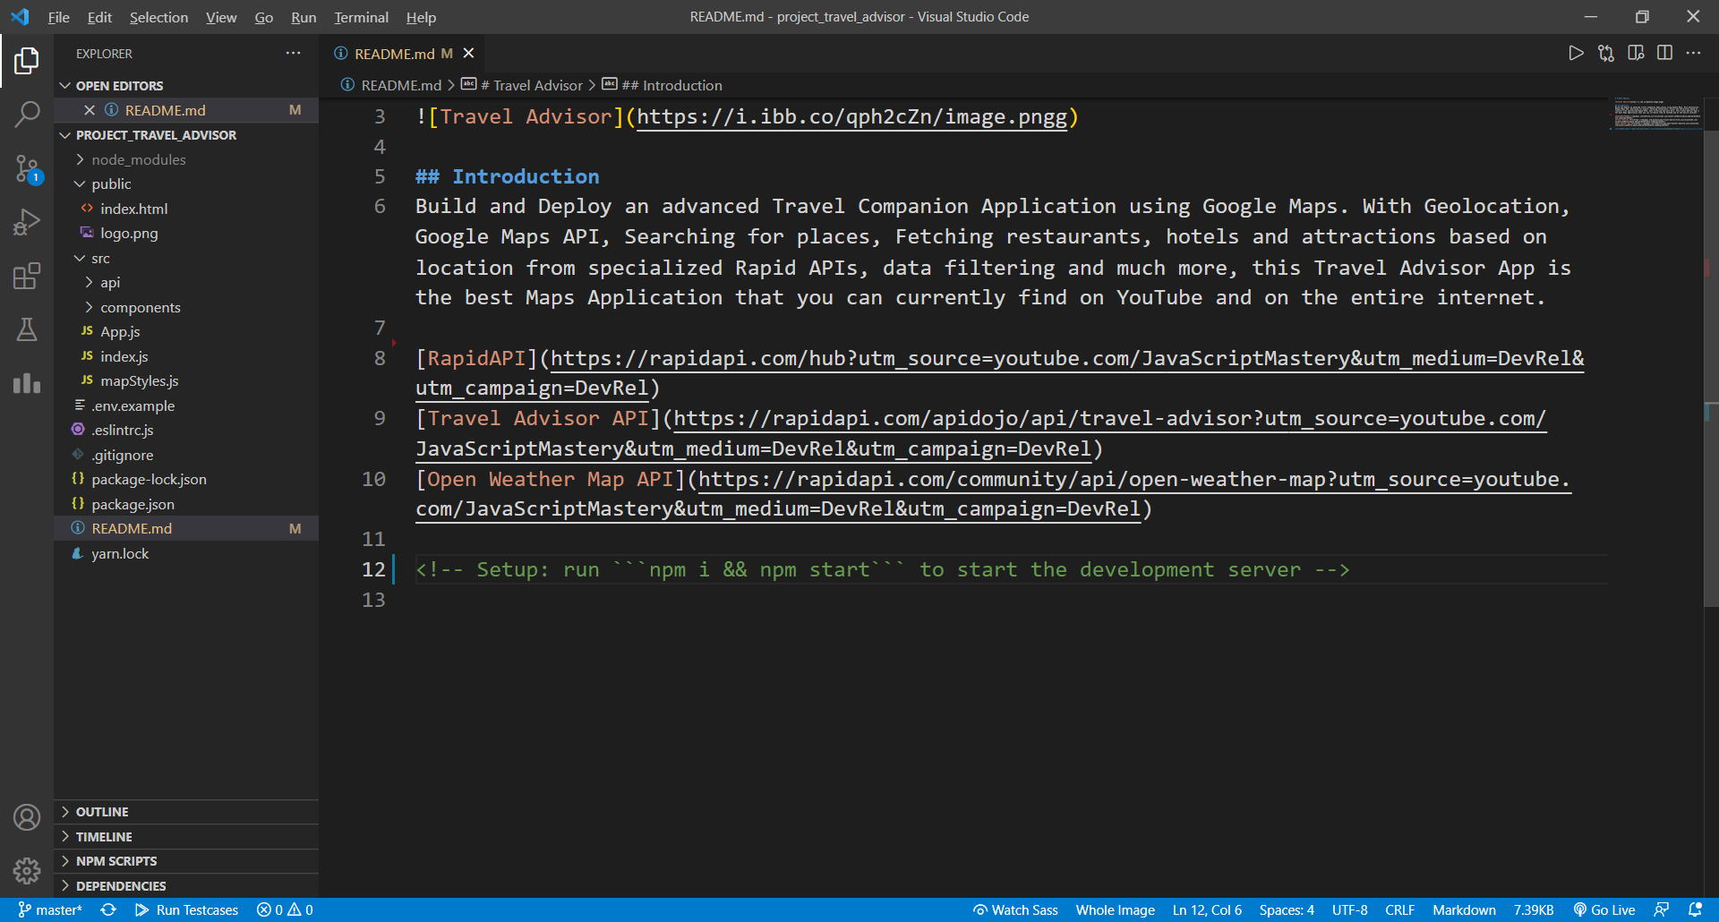

**Package.json**

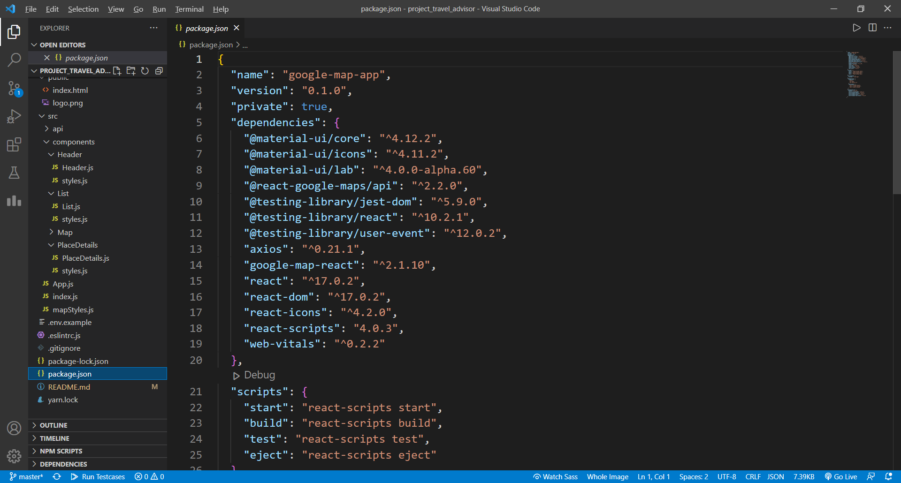

**Development Phase of Project**

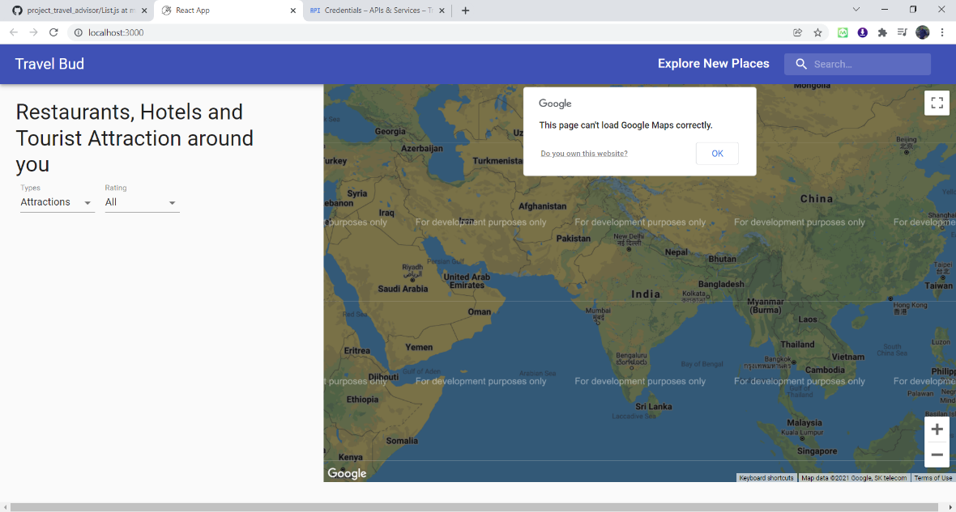

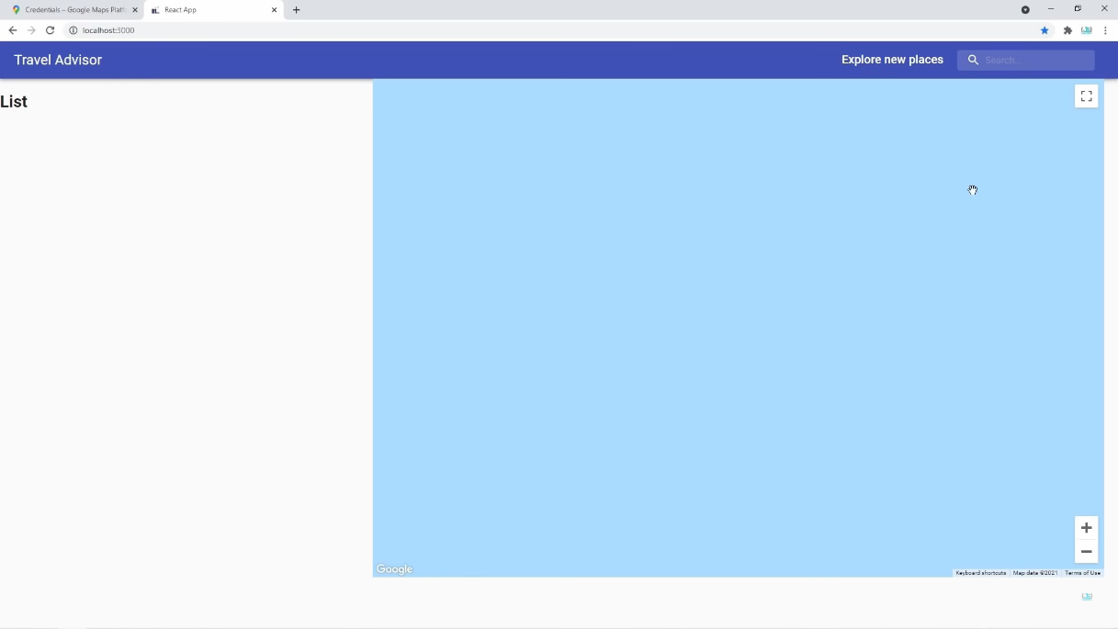

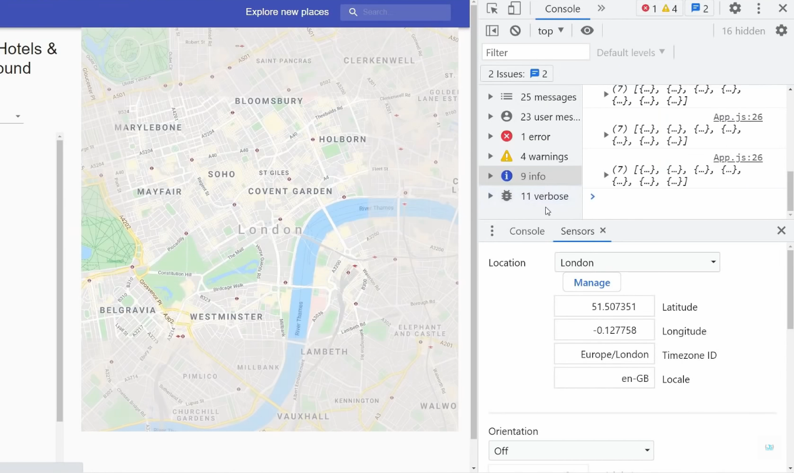

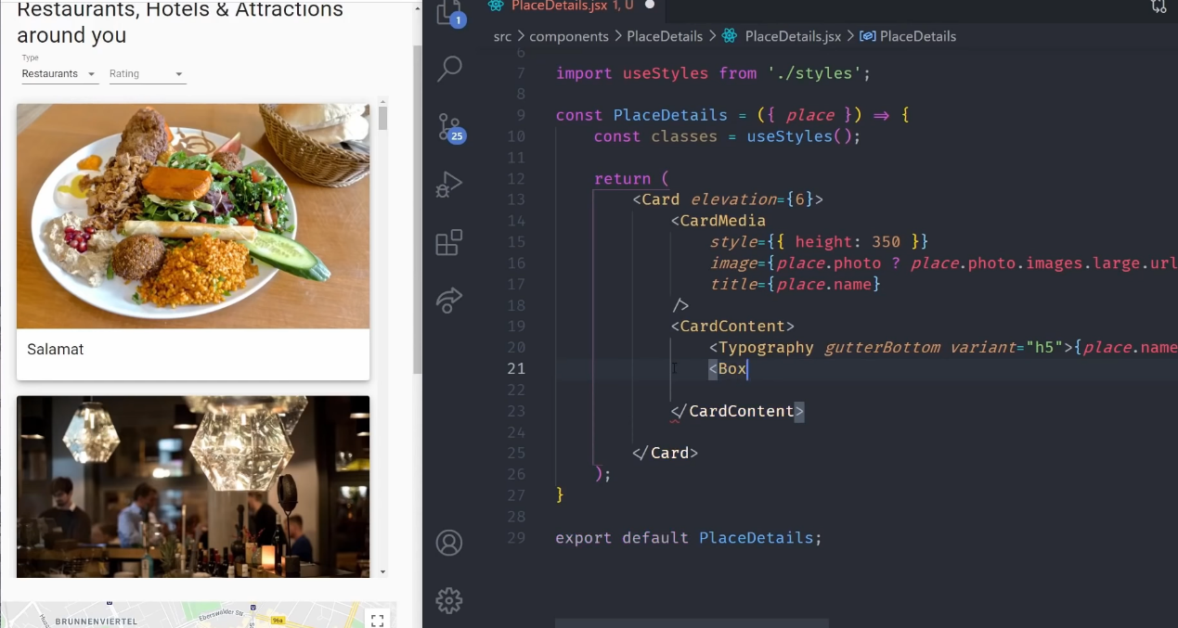

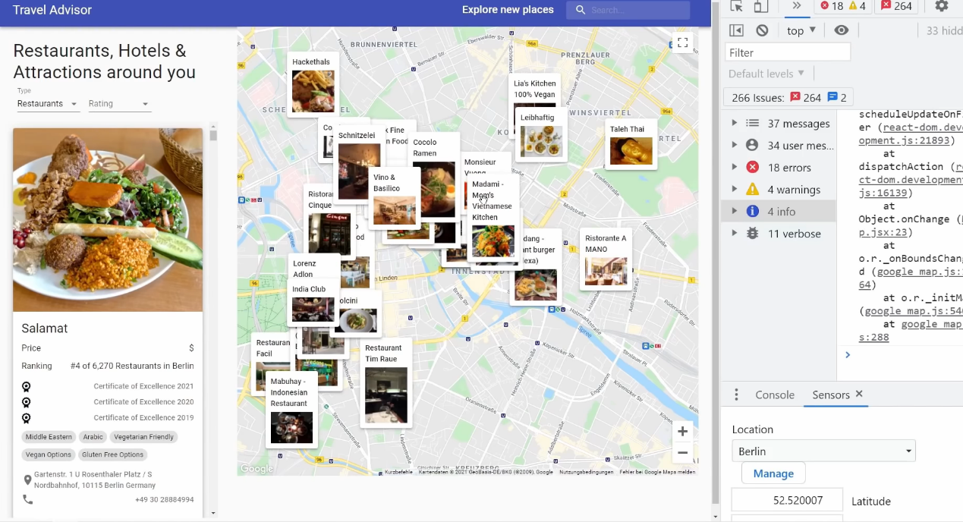

**CHAPTER :07**

**TESTING**

**7.1 TESTING USED**

**WHITE BOX TESTING:**

White box testing techniques analyze the internal structures the used data structures, internal design, code structure and the working of the software rather than just the functionality as in black box testing. It is also called glass box testing or clear box testing or structural testing.

**Working process of white box testing:**

* **Input:** Requirements, Functional specifications, design documents, source code.
* **Processing:** Performing risk analysis for guiding through the entire process.
* **Proper test planning:** Designing test cases so as to cover entire code. Execute rinse-repeat until error-free software is reached. Also, the results are communicated.
* **Output:** Preparing final report of the entire testing process.

With the help of this testing we were able to verify the following problems :

* + Internal security holes
  + Broken or poorly structured paths in the coding processes
  + The flow of specific inputs through the code
  + Expected output
  + The functionality of conditional loops
  + Testing of each statement, object, and function on an individual basis

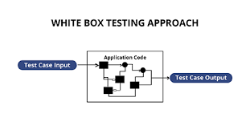

Figure : 12

**7.2 TEST CASES AND RESULT**

**LOGIN PAGE**

* 1. **Using Search Bar**

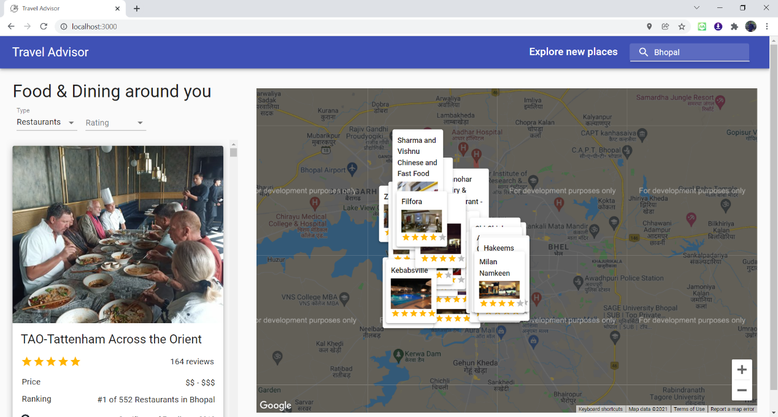

* 1. **Using Filters**

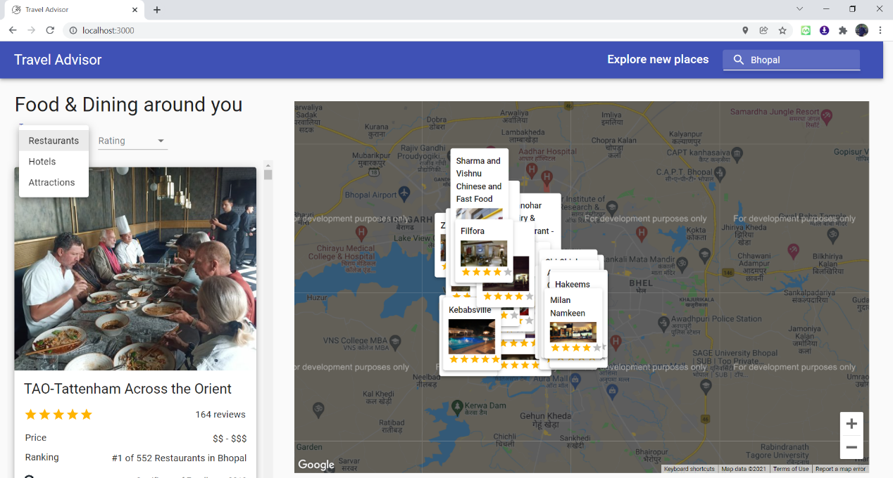

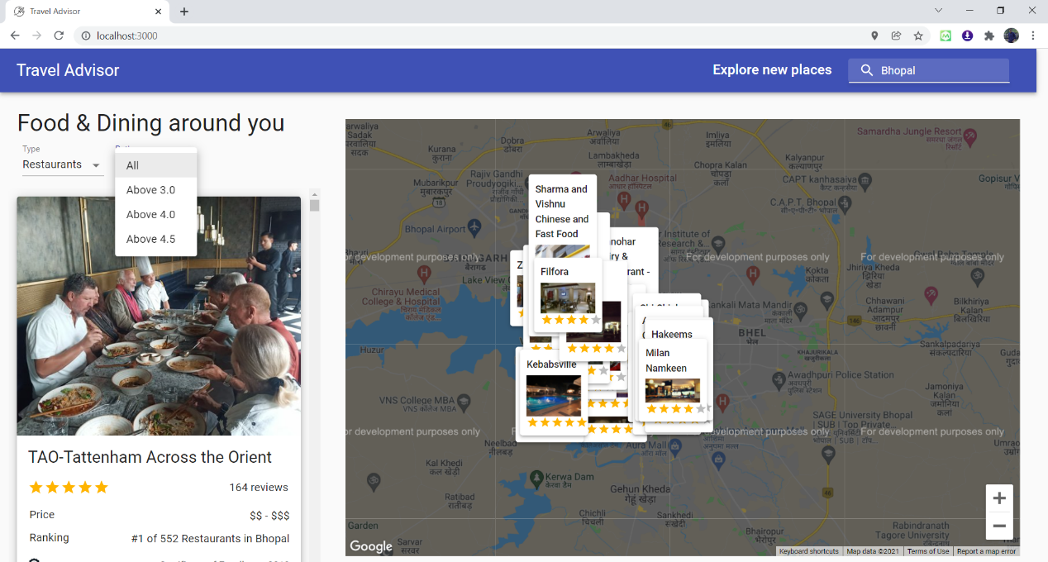

* 1. **Choosing Favourite Location on Map**

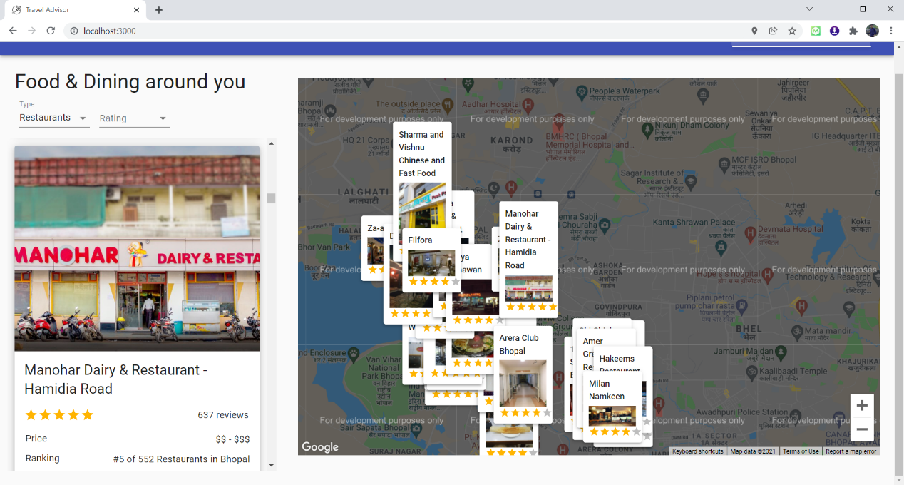

* 1. **Using Map to choose a location for viewing places**

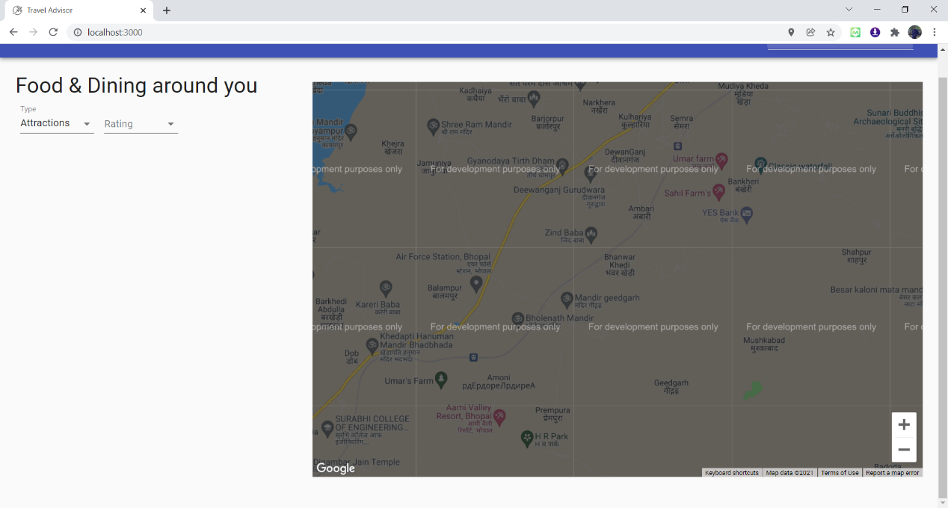

**CHAPTER : 09**

**FUTURE ENHANCEMENTS**

* The user interface will need a lot of improves, as users nowadays really focus on how the application look like.
* The application should work with picture as well.
* One of the biggest challenges will be creating chat between travel user can guide user, in order to allow two group to talk with each other on the application.
* Sign up, Login with Social media.
* Direct Booking of Hotels, or tables is restaurants, or spot in tourist attractions.
* Directions link so that one can view it in their mobile phones.
* Convert this concept into an native mobile application.

**CHAPTER :10**

**CONCLUSION**

The purpose of the work is to create an application, in order to allow travelers and local people meet each other, communicate and learn about new cultures and places. The core function is to let two groups communicate with each other, which is basically completed. However, the application will need a huge improvement with a team of deep knowledgeable people and a long time to fix all the flaws.

This Website Development Project gave us sound knowledge and experience in all major areas of computer application and to get exposure to various technical and management practices of IT industry.

In the conclusion I would like to say that Technology has made significant progress over the years to provide consumers a better online shopping experience and will continue to do so for years to come.  With the rapid growth of products and brands, people have speculated that online shopping will overtake in-store shopping.  While this has been the case in some areas, there is still demand for brick-and-mortar stores in market areas where the consumer feels more comfortable seeing and touching the product being bought.  However, the availability of online shopping has produced a more educated consumer that can shop around with relative ease without having to spend a large amount of time.  In exchange, online shopping has opened up doors to many small retailers that would never be in business if they had to incur the high cost of owning a brick-and-mortar store.  At the end, it has been a win-win situation for both consumer and sellers.

Even though the application seems to be simple, I met a huge challenge since this is the first time that I use a new technology that I do not know from before and build it from 0. The time to learn and read about all necessary technologies is long. But the most difficult part is to start coding and implementing. There are too many errors which are new, and it takes a bit of time in order to wait for the developers of ReactJS find a solution

**CHAPTER :10**

**REFERENCES**

1. Moulana Mohammed, et al. " Prediction Of Rainfall Using Machine Learning Techniques"

INTERNATIONAL JOURNAL OF SCIENTIFIC & TECHNOLOGY RESEARCH

VOLUME 9, ISSUE 01, JANUARY 2020.

<http://www.ijstr.org/final>[-print/jan2020/Prediction-Of-Rainfall-Using-Machine](http://www.ijstr.org/final-print/jan2020/Prediction-Of-Rainfall-Using-Machine-Learning-Techniques.pdf)-[Learning](http://www.ijstr.org/final-print/jan2020/Prediction-Of-Rainfall-Using-Machine-Learning-Techniques.pdf)- [Techniques.pdf](http://www.ijstr.org/final-print/jan2020/Prediction-Of-Rainfall-Using-Machine-Learning-Techniques.pdf)

1. Umair Ahmed , et al. “Efficient Water Quality Prediction Using Supervised Machine

Learning” ,School of Electrical Engineering and Computer Science (SEECS), National

University of Sciences and Technology (NUST), Islamabad 44000, Pakistan

Received: 1 September 2019; Accepted: 17 October 2019; Published: 24 October 2019 https://www.mdpi.com

1. Kaushik Dutta, et al. “Rainfall Prediction using Machine Learning and Neural Network”, International Journal of Recent Technology and Engineering (IJRTE) ISSN: 2277-3878, Volume-9 Issue-1, May 2020.

<https://www.ijrte.org/wp>[-content/uploads/papers/v9i1/A2747059120.pdf](https://www.ijrte.org/wp-content/uploads/papers/v9i1/A2747059120.pdf)

1. Muthukumar.J

<https://www.kaggle.com/muthuj7/weather>[-dataset](https://www.kaggle.com/muthuj7/weather-dataset)

1. Aditya Kadiwal**,** Senior Data Engineer at Blazeclan Technologies Pvt. Ltd.,Pune , Maharashtra, India

<https://www.kaggle.com/adityakadiwal/water>[-potability](https://www.kaggle.com/adityakadiwal/water-potability)

**CHAPTER :11**

**PUBLISHED PAPER WITH CERTIFICATE**

**PAPER DETAILS**

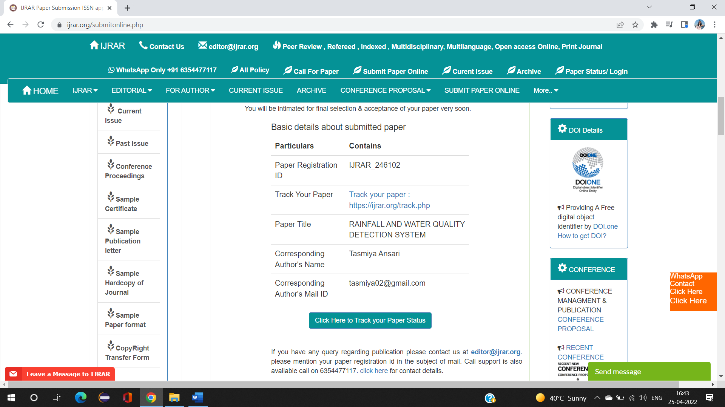



**ACEEPTANCE LETTER**

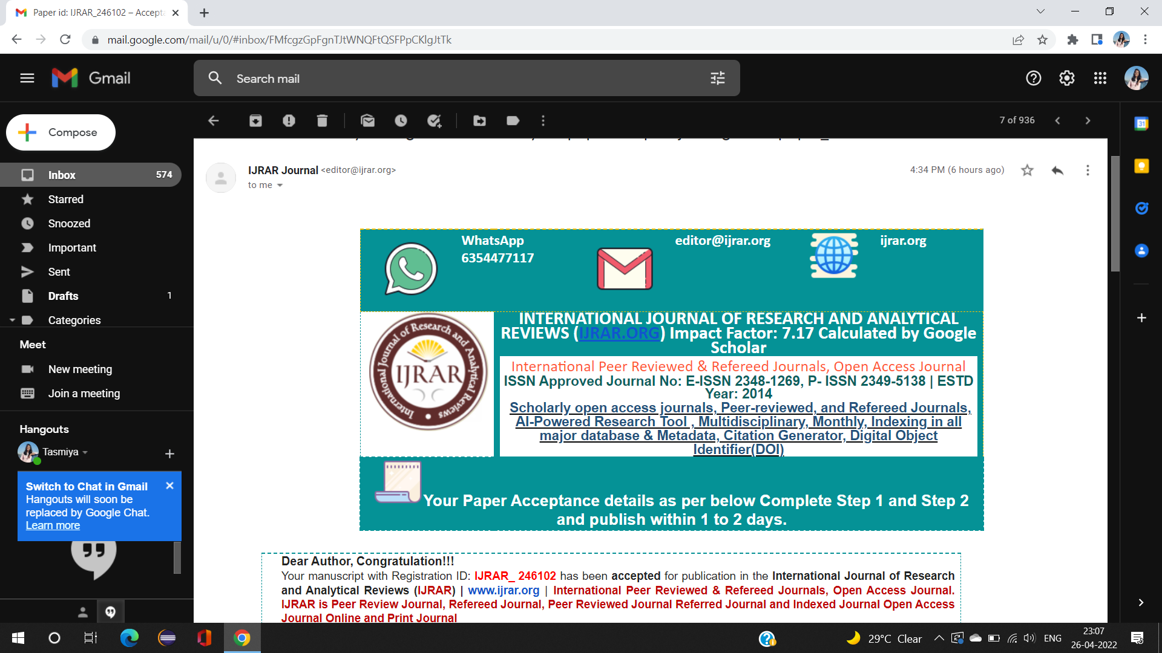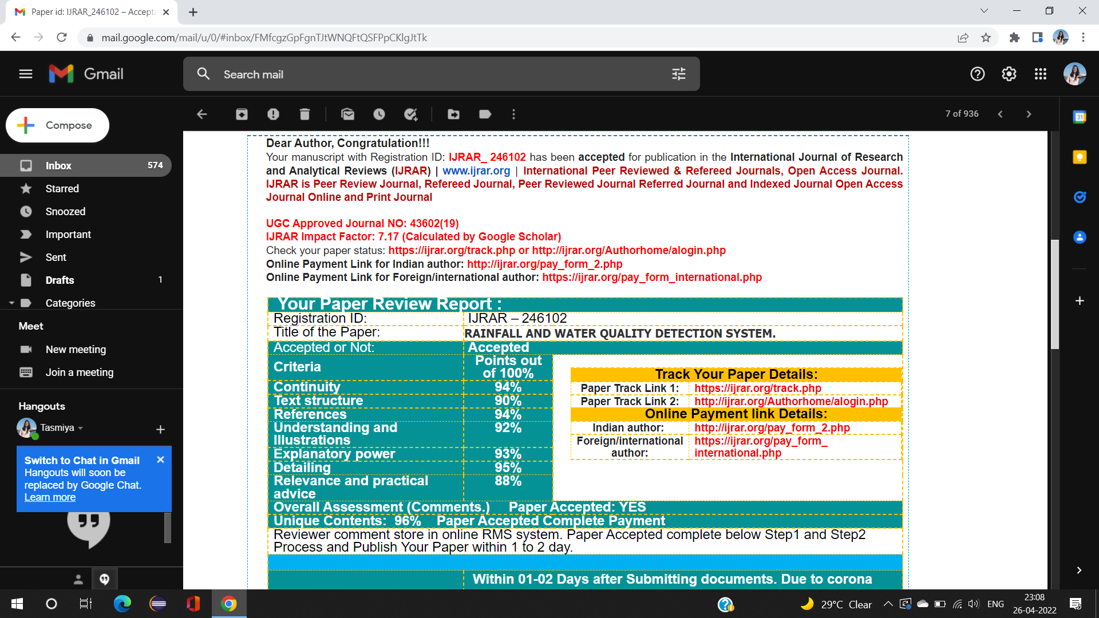

**BIBLIOGRAPHY**

<https://stackoverflow.com/>

<https://www.flipkart.com/>

<https://www.diagrams.net>

<https://www.geeksforgeeks.org/>